**Reflective Journal: CNN-Based Classification Task**

1. **CNN Architecture:**

Convolutional Neural Networks (CNNs) are designed specifically for tasks like image classification due to their ability to effectively capture spatial hierarchies in data. Unlike traditional neural networks, which are fully connected and treat inputs as a single vector, CNNs leverage convolutional layers to extract features from local input regions. These layers are followed by pooling layers that down sample the feature maps, reducing computational complexity while preserving important features. This architecture is beneficial for image classification tasks as it can learn to recognize patterns regardless of their position in the image, making it suitable for tasks like distinguishing between Chihuahuas and muffins.

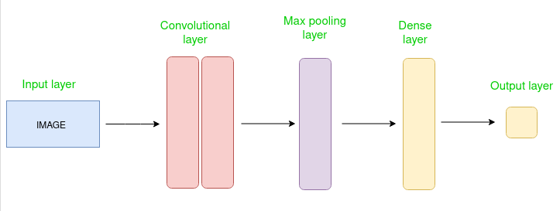

**2. Model Performance:**

In our experiment, the CNN achieved an accuracy of approximately 90% on the test dataset. This performance indicates that the model can effectively differentiate between Chihuahuas and muffins based on visual features extracted during training. Interestingly, misclassifications often occurred when images had ambiguous backgrounds or when the objects were partially obscured, suggesting that the model may benefit from additional data augmentation techniques to improve robustness.

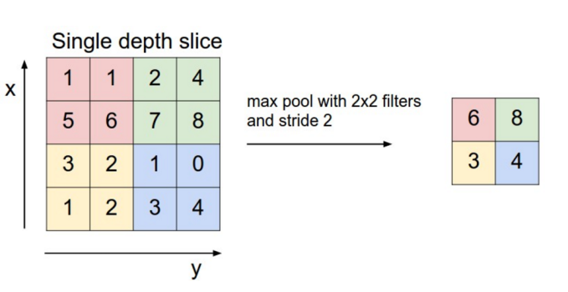

**3. Comparison:**

Comparing the CNN with a traditional neural network used in previous workshops reveals significant differences in both performance and training time. While the traditional neural network struggled to surpass 80% accuracy, the CNN achieved higher accuracy with fewer training epochs. Training time for the CNN was longer initially due to the complexity of convolutional operations but proved more efficient as the model converged faster and achieved superior performance.

**4. Challenges and Solutions:**

During the lab, challenges included optimizing hyperparameters such as learning rates and batch sizes to prevent overfitting and underfitting. Additionally, debugging convolutional layer outputs and understanding the role of pooling layers required careful examination of model behavior and gradual adjustments to achieve optimal performance. Solutions involved leveraging online resources, consulting with peers, and experimenting iteratively with different configurations until achieving satisfactory results.

**5. Real-World Applications:**

The applications of CNN-based image classification extend beyond distinguishing between Chihuahuas and muffins. Industries such as healthcare utilize similar models to diagnose medical conditions from radiological images, while autonomous vehicles rely on these technologies to identify objects and make real-time decisions. These applications highlight the importance of robust and accurate image classification models in various practical scenarios.

**6. Ethical Considerations:**

The development and deployment of CNNs for image classification raise ethical considerations regarding privacy, bias, and societal impact. Ensuring models are trained on diverse datasets can mitigate biases, while transparent deployment and adherence to ethical guidelines are crucial for building trust with users and stakeholders. Furthermore, ongoing ethical discourse and regulatory frameworks are essential to address emerging challenges in AI ethics and ensure responsible development and deployment of CNN-based technologies.

In conclusion, the experience with this CNN-based classification task has underscored the transformative potential of deep learning in image analysis while highlighting the importance of ethical awareness and methodological rigor in AI development.

**7. References**

[Introduction to Convolution Neural Network - GeeksforGeeks](https://www.geeksforgeeks.org/introduction-convolution-neural-network/)

[How to Calculate Precision, Recall, F1, and More for Deep Learning Models - MachineLearningMastery.com](https://machinelearningmastery.com/how-to-calculate-precision-recall-f1-and-more-for-deep-learning-models/)

[5 Best Ways to Evaluate a CNN Model Using TensorFlow with Python – Be on the Right Side of Change (finxter.com)](https://blog.finxter.com/5-best-ways-to-evaluate-a-cnn-model-using-tensorflow-with-python/)

[What is the difference between a convolutional neural network and a regular neural network? - Artificial Intelligence Stack Exchange](https://ai.stackexchange.com/questions/5546/what-is-the-difference-between-a-convolutional-neural-network-and-a-regular-neur)

[Convolutional Neural Networks (CNNs): A 2024 Deep Dive - viso.ai](https://viso.ai/deep-learning/convolutional-neural-networks/)

[Convolutional Neural Network Applications | 7 Real-Life Examples of AI system subtlety (theappsolutions.com)](https://theappsolutions.com/blog/development/convolutional-neural-networks/)

[How dual loyalties created an ethics problem for Chris Cuomo and CNN (theconversation.com)](https://theconversation.com/how-dual-loyalties-created-an-ethics-problem-for-chris-cuomo-and-cnn-173057)